**Troubleshoot Techniques - Azure App services**

**PerfView:** (<https://github.com/TheAzureGuy007/perfview>)

For analyzing issues in APP service you can use "**PerfView**"

When you run PerfView.exe it gives out to enter the process name for which we want to analyze the performance

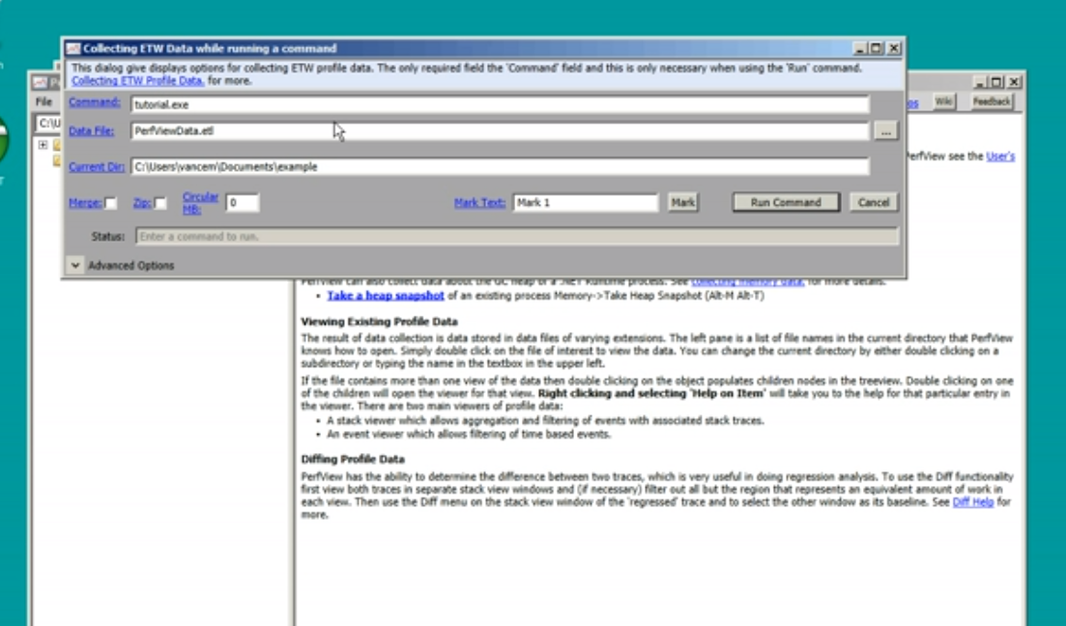

After processing it pops up all of the system threads even, select the one which we want

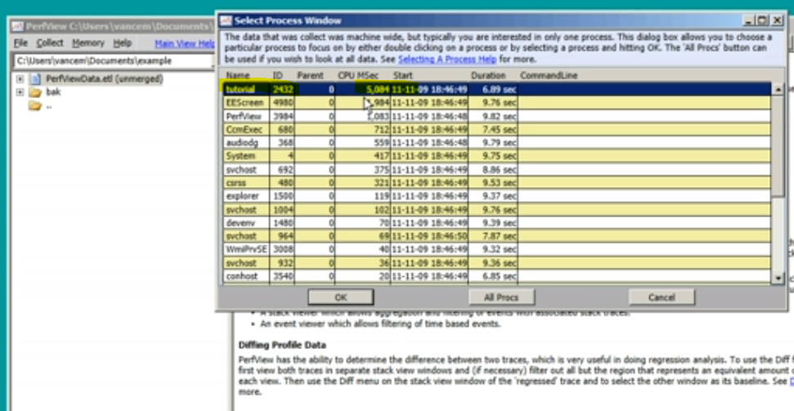

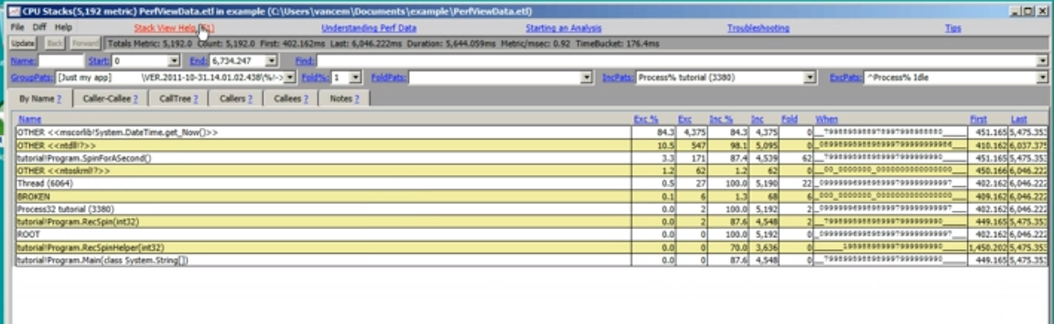

**Various views**

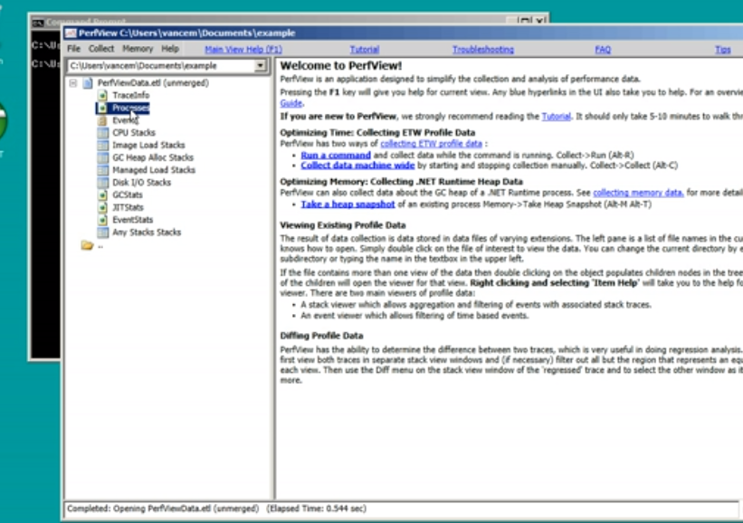

**Kudu Process Explorer**

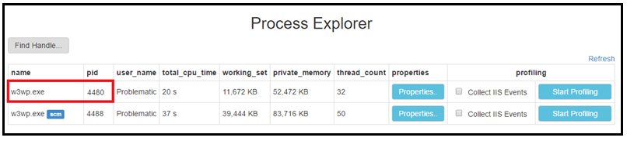

**IIS Profiling**

IIS profiling enables IIS and threadTime ETW events. The generated trace file can be analyzed using Perfview which is available at <https://www.microsoft.com/en-us/download/details.aspx?id=28567>.

The profiling session will automatically timeout after **180** seconds if not stopped manually.

Enabling IIS Profiling is a relatively **expensive option** to turn on as it increases the CPU usage and disk I/O on your instance. Are you sure you want to continue?

Secure https://webapp-gk.scm.azurewebsites net/PracessExplarer/ 
u Environment 
Debug console • 
Process explorer 
Tools 
Site extensions 
Find Handle_ 
name 
w3wp.exe 
user name 
WeöApp- 
total c 
6756 
Process Explorer 
Collect IIS Events? 
IIS profiling enables IIS and threadTime E TW events The generated 
trace file can be analyzed using Perfvlew which is available at 
https:\/mvw.microsoft 
The profiling session will automatically timeout after 180 seconds if not 
stopped manually. 
Enabling IIS Profiling is a relatively expensive option to turn on as it 
increases the CPU usage and disk I/O on your instance. Are you sure 
profiling 
Collect IIS Events 
girish.k@ze 
Retresh 
Start Profiling 
pu want to continue? 
Yes 
No 

LOG O/P:

Machine generated alternative text:
- Microsoft Visual Studio 
Eile Edit Yiew project Debug Team 1001s Test Analyze 
CPU Usage - profil...wp_6756.diagsession 
Zoom In Reset Zoom 
Clear Selection 
Diagnostics session: 2:41 minutes (2:41 min selected) 
CPU (% of all processors) 
Function Name 
w3wp.exe (PID. 6756) 
DWASMod.dll!Ox0000007266db5e 
DWASMod.dll!Ox0000007266db10 
System.Threading.Tasks.TaskHeIpersExtensionsz•C... 
System.Threading.Tasks.TaskHeIpersExtensionsz•C... 
System.Threading.Tasks.TaskHeIpersExtensionsz•C... 
M icrosoft.Owin. Host. In tegratedPipeIi... 
System .Web .WebPages. BrowserHeIp 
System Web WebPages. DisplayModeProvider:: < .c... 
System Web WebPages. 
Syste m .We b .WebPag es.Web Pag e Ro ute:: GetRout... 
System We b WebPages.WebPageRoute*atchRe... 
System Web WebPages.Web Page Route •Do Post 
System.Web.WebPages.WebPageHttpModuIe:Om 
iisnodedII!Ox000000728e7f7d 
Total CPU [ms, 0/0]. 
242 (10000%) 
37 
7 (2890/4 
2 (0830/4 
1 (0410/4 
1 (0410/4 
1 (0410/4 
1 (0410/4 
1 (0410/4 
1 (0410/4 
1 (0410/4 
1 (0410/4 
1 (0410/4 
1 (0410/4 
1 (0410/4 
1 (0410/4 
Window Help 
Attach... • 
Self CPU 0/0] 
242 (10000%) 
O (000% 
O (000% 
1 (0410/4 
1:15min 
Module 
w3wp. exe 
DWASModdll 
Anonymously Hosm 
DWASModdll 
Microsoft.Owin.H... 
Microsoft.Owin.H... 
Microsoft.Owin.H... 
Microsoft.Owin.H... 
System.Web.Web... 
System.Web.Web... 
System Web. Web... 
System.Web.Web... 
System.Web.Web... 
System.Web.Web... 
System Web. Web... 
iisnodedll 

- Microsoft Visual Studio 
Eile Edit Yiew project Debug Team 1001s Test Analyze 
CPU Usage - profil...wp_6756.diagsession 
Zoom In 
Reset Zoom 
Clear Selection 
Diagnostics session: 2:41 minutes (2.526 s selected) 
Quick Launch (Ctrl+Q 
Window Help 
Attach... • 
Girish Kalamati • 
Process CPU usage 
CPU (% of all processors) 
Function Name 
w3wp.exe (PID: 6756) 
Create detailed report.„ 
V Filter • 
Search 
Total CPU [ms, 0/0]. 
52 (100.00%) 
Self CPU 0/0] 
Module 
52 (100.00%) w3wpexe 
No user code was running during the sekcted time rGnge 

Chrome developer Tools (Page **Profiling**)

Secure https://webapp-gk.scm.azurewebsites.net/DebugConsole/?sheIl=powershell 
Kudu 
Environment Debug console • 
Name 
data 
Process explorer 
Tools 
Site extensions 
Audits 
12310ms 
2120 ms 
girish.k@zen3.com 
Modified 
8/20/2018, 846143 PM 
Elem ents Console Sources Network 
webspp-gk.scm.ezu 
Performance 
Screenshots 
12280ms 
Arimetic 
Memory 
Memory 
sco_7 
Application 
2240 ms 
12250 ms 
12270ms 
122goms 
Security 
1 2300 ms 
12320 ms 
12330 ms 
12340ms 
1 Ico_7n-é 
12350 ms 
12co_7 
1 2360 ms 
Eco: 
12370ms 
theme-github.js (functions.. 
Frames 
Interyctions 
Main — https:/,Qbapp-gk.scm.azurewebsites.net,•'DebugConsoIe/?sheII=powerfreII 
Event (DOMContentLoaded) 
m on rame I 
Function Call (ace.js:l) 
JS Heap[lll MB - 11.2 MB) Documentsg-5) Nodes[1 576-1 6251 Listeners[85-g11 Memory 
Summary 
Bottom - U p 
Call Tree 
Event Log 